|  |
| --- |
| **Exercise 4** |

**Copy this file and open it in Word or some other editor where you can insert images. Be sure to read "How to Copy the Results of a Query" found in Module 2 in Canvas.    This is how you will be answering the following questions.**

Using the Premier Products database:

1. Using a function, what is the price of the most expensive part of the database?

Insert your query and results here.

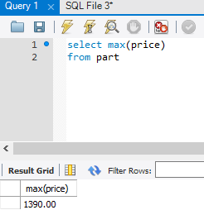

2. Using functions, what is the part number, description, and on hand value of each part whose number of units on hand is more than the average number of units on hand for all parts?   Insert your query and results here.

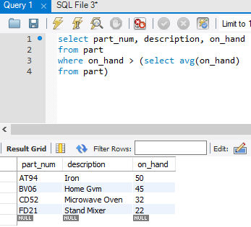

3. How many customers have balances that are less than their credit limits?   Use the count function here.   Insert your query and results here.

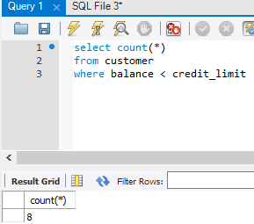

4. Using a function, list the sum of the balances of all customers for each sales rep.   Order and group the results by sales rep number.   Insert your query and results here.

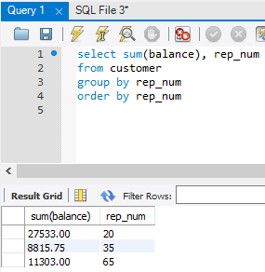

5. List by warehouse the count of the number of items that have an on hand amount less than 20 items.  Only display those warehouses that have more than one item that is less than 20 on hand.   Insert your query and results here.

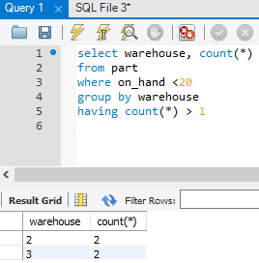

Using the Henry Books database:

6. How many book copies have a price that is between $20 and $25? Insert your query and results here.

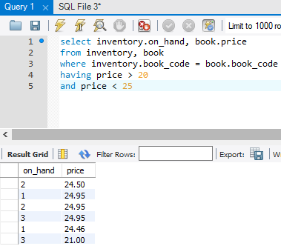

7. How many employees are employed at Henry Books? Insert your query and results here.

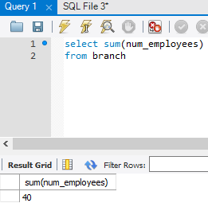

8. What is the total number of books by branch? Insert your query and results here.

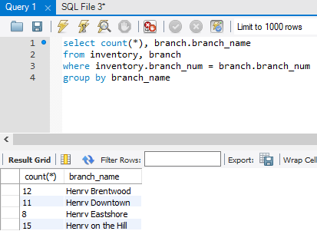

9. Which book costs the most? Display the title of the book, its price, and the publisher name. Insert your query and results here.

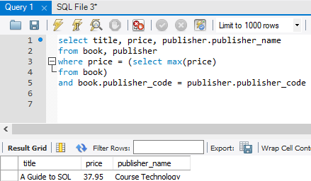

10. List the branch number and the count of the number of times that a branch has more than 3 copies of a book available. Do not display the individual books. Only display this information (the branch number and the count) if a branch has more than one instance of more than 3 copies of a book. Insert your query and results here.

